**SQL JOINS**

**Name- Anas Jawed**

Create three tables: salesman, customer and orders.

* SALESMAN (SALESMAN_ID, NAME, CITY, COMMISSION)
* CUSTOMER (CUSTOMER_ID, CUST_NAME, CITY, GRADE, SALESMAN_ID)
* ORDERS (ORDER_NO, ORDER_AMT, ORDER_DATE, CUST_ID, SALESMAN_ID)

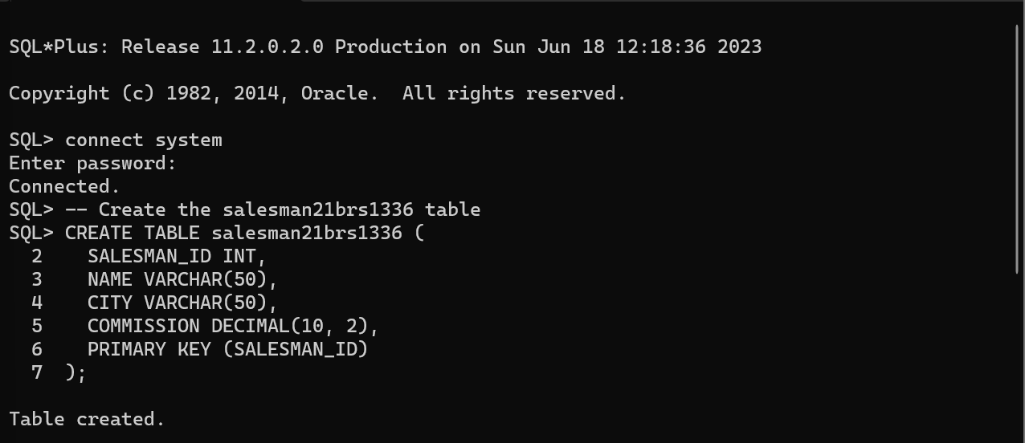

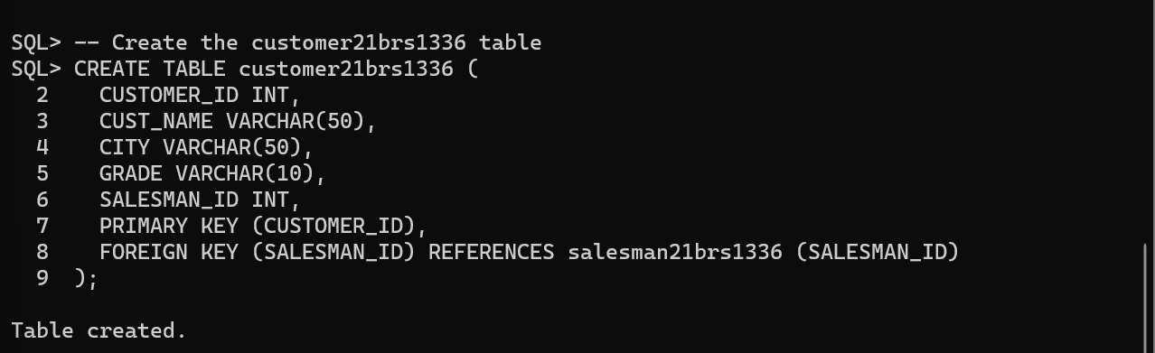

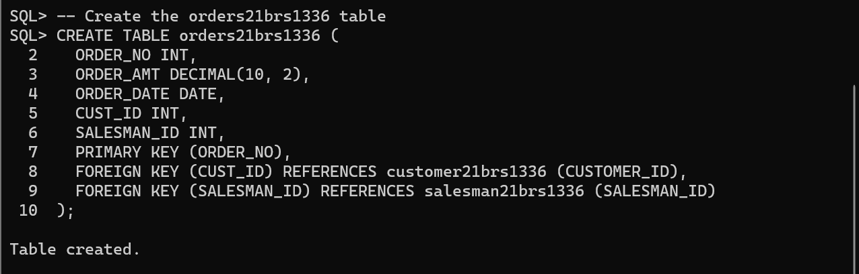

**Note**: Do not forget to naming tables with last four digits of your Roll.No.

**Note**: here if commission is written as 0.08 means the salesman gets 0.08 X 100=8% commission.

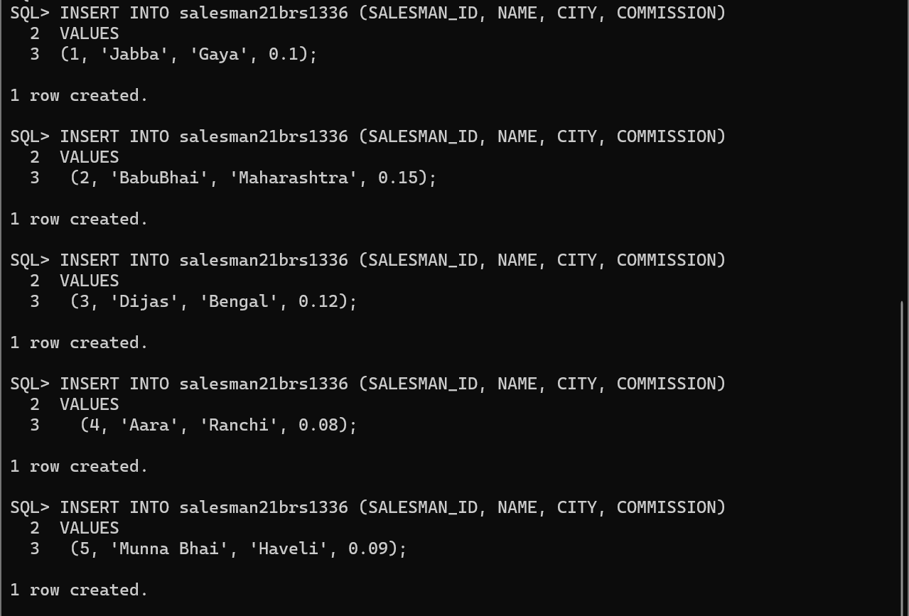

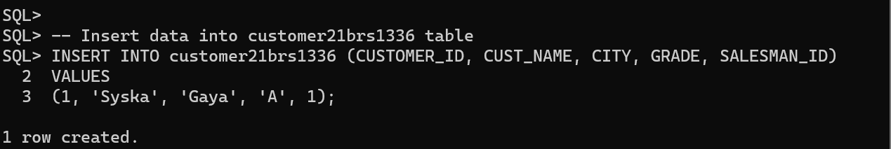

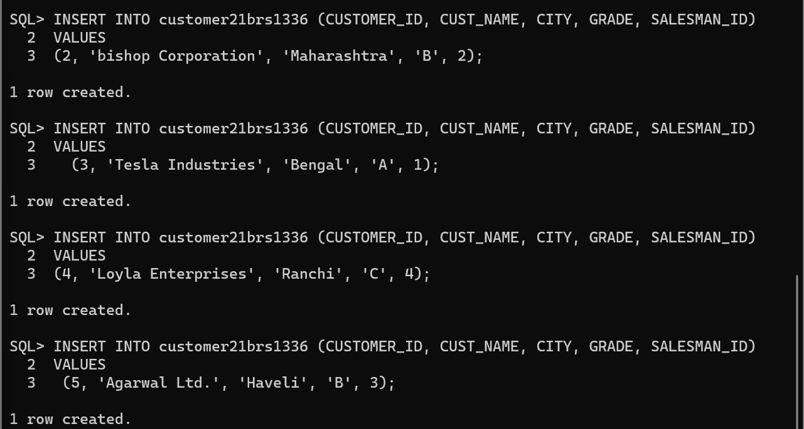

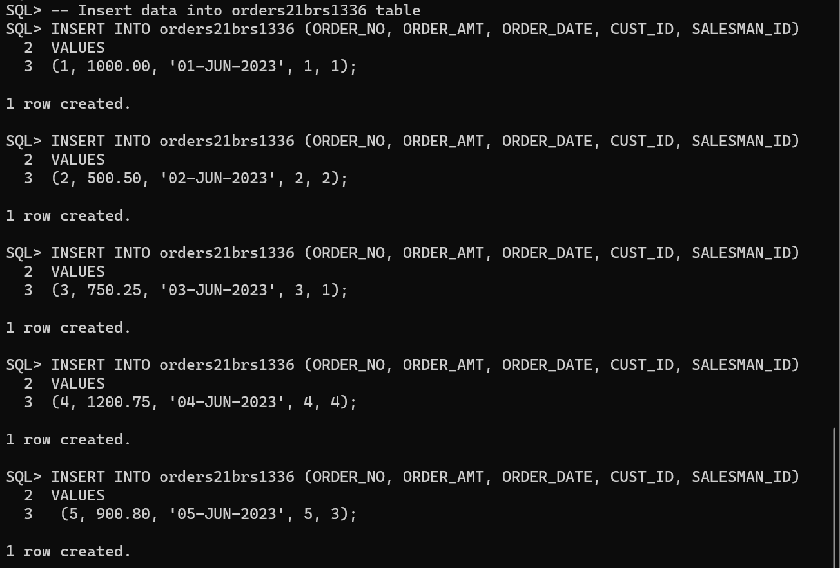

Write SQL statement to

1. 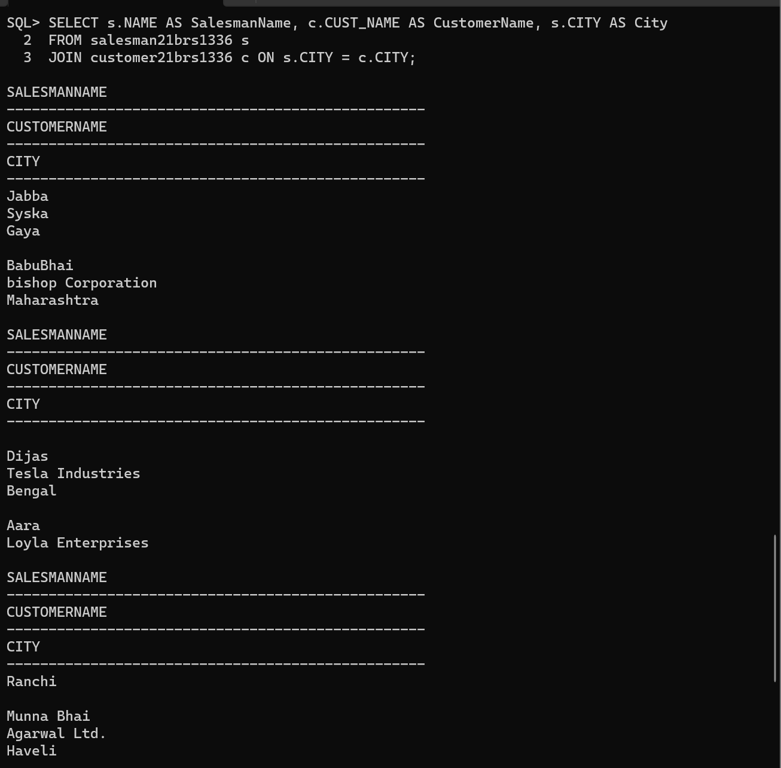Prepare a list with salesman name, customer name and their cities for the salesmen and customer who belongs to the same city.
2. Make a list with order no, purchase amount, customer name and their cities for those orders which order amount between 500 and 2000.

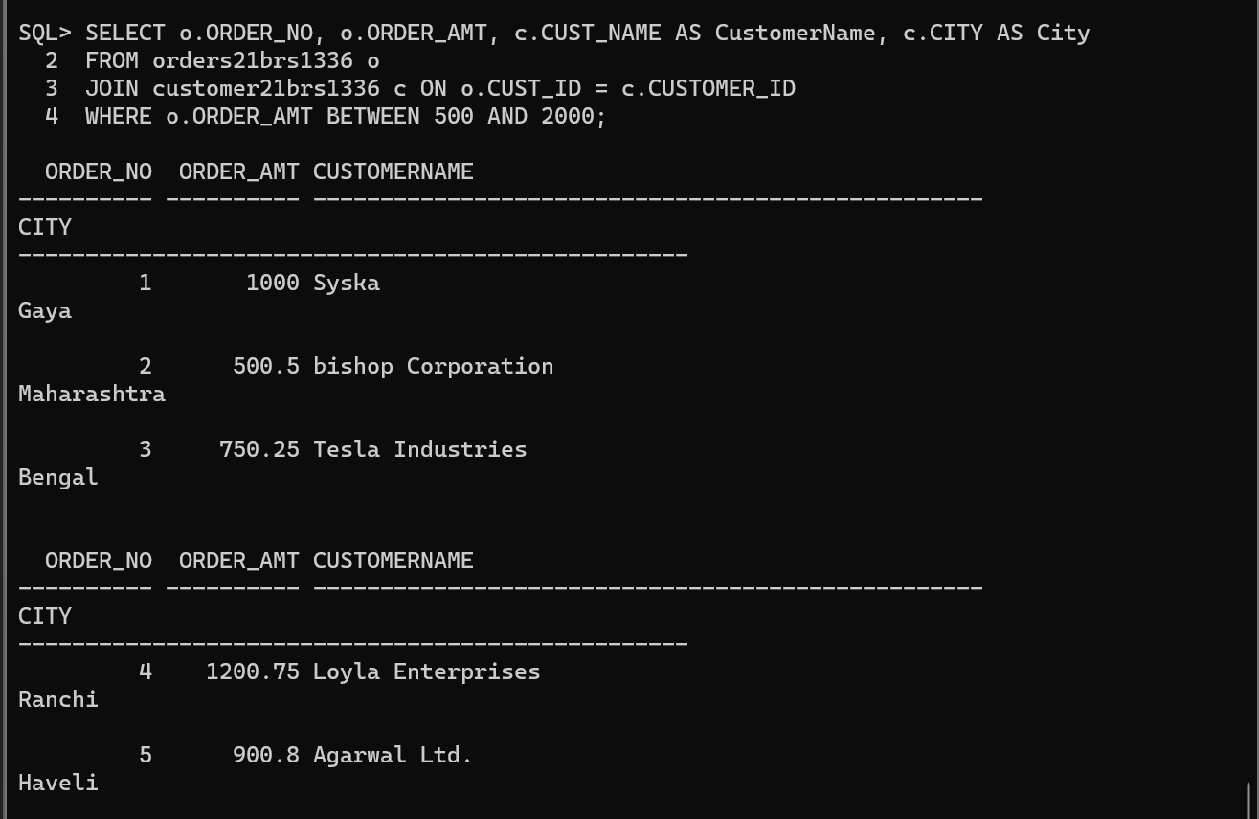

1. Know which salesman is working for which customer.

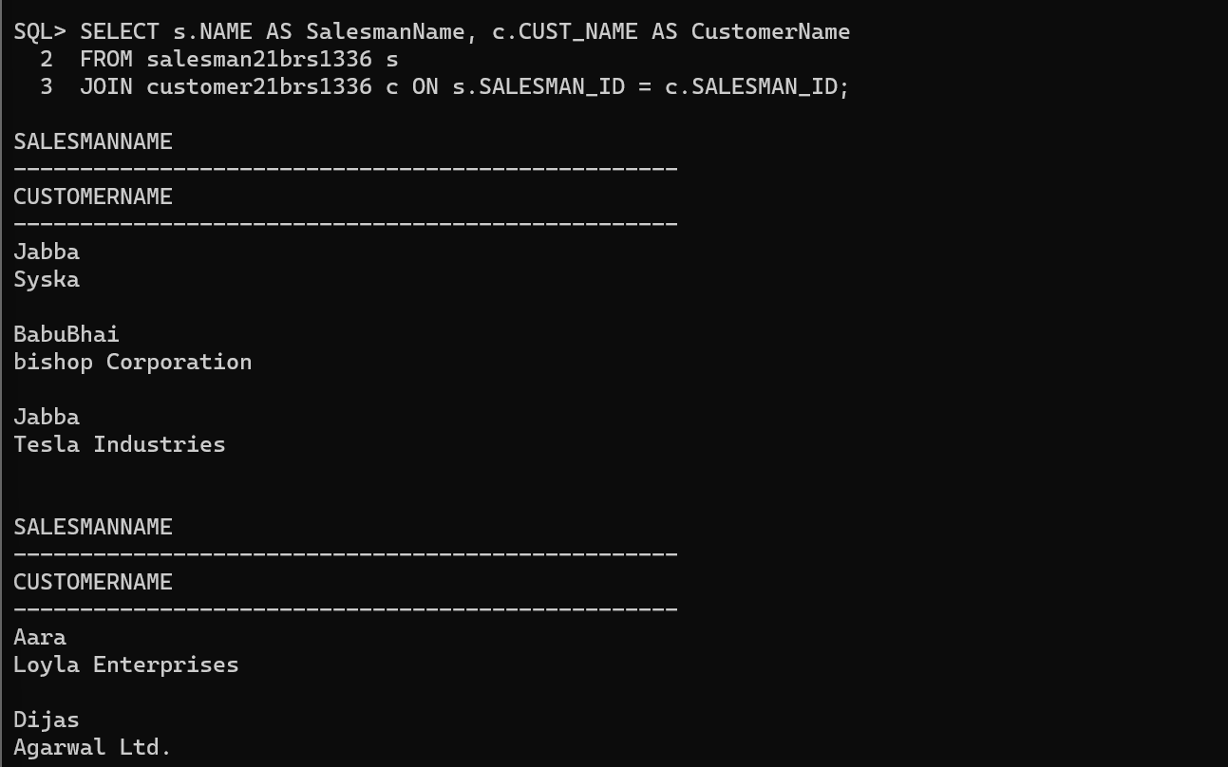

1. Find the list of customers who appointed a salesman for their jobs who gets a commission from the company is more than 12%.
2. 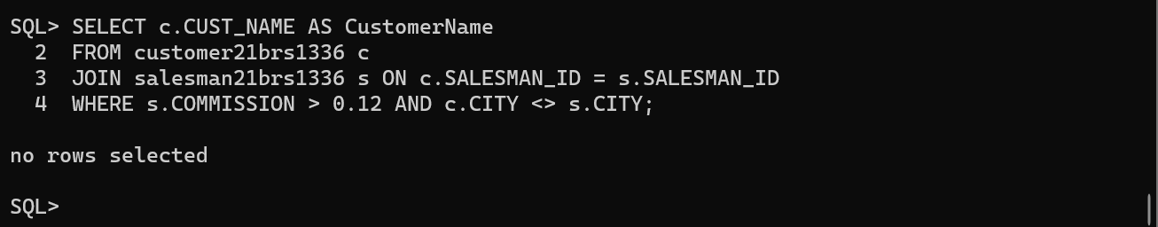Find the list of customers who appointed a salesman for their jobs who does not live in the same city where their customer lives, and gets a commission is above 12%
3. Find the details of an order i.e., order number, order date, amount of order, which customer gives the order and which salesman works for that customer and how much commission he gets for an order.



1. 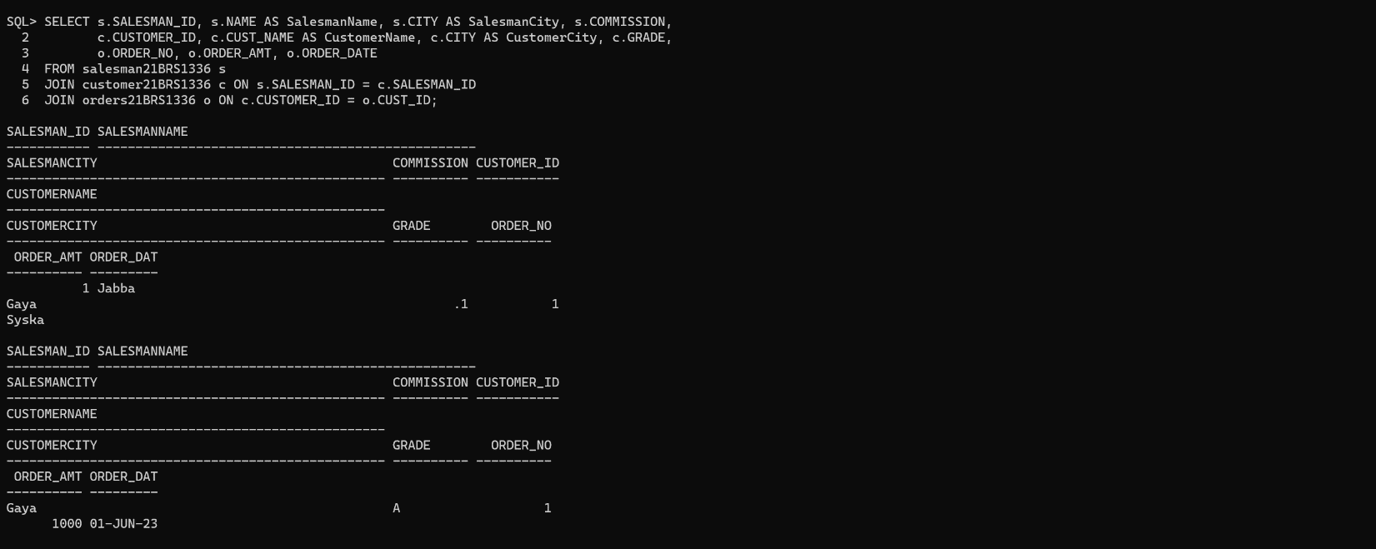Make a join on the tables: salesman, customer and orders in such a form that the same column of each table will appear once and only the relational rows will come.

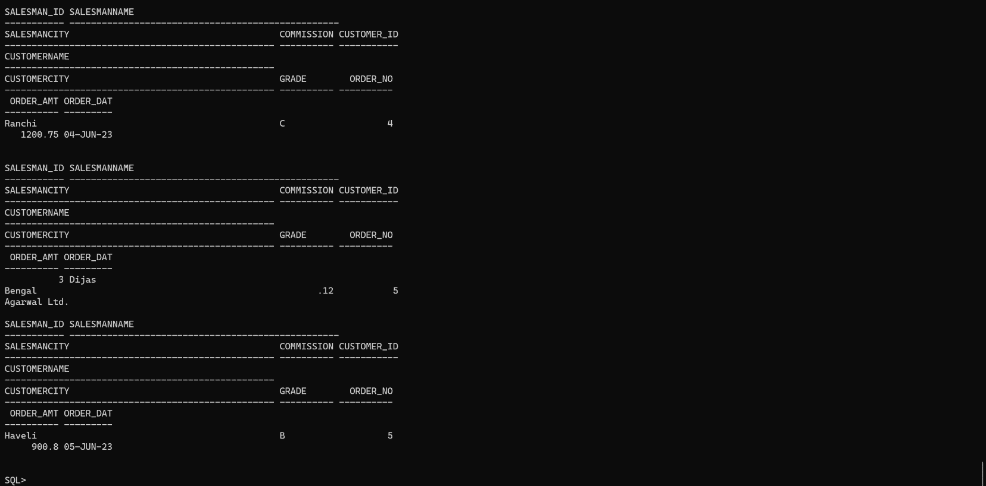

1. 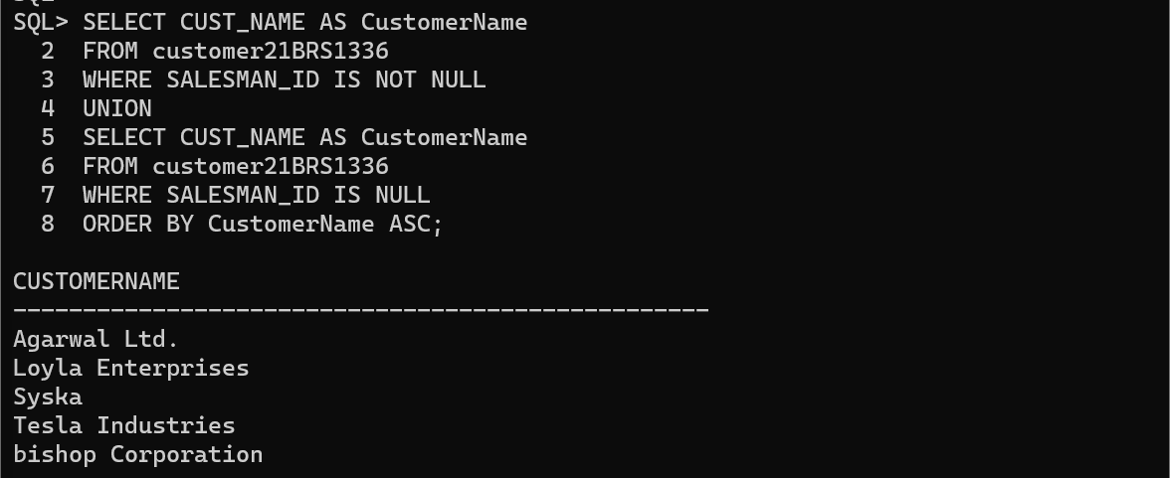Make a list in ascending order for the customer who works either through a salesman or by own.
2. Make a list in ascending order for the customer who holds a grade less than 300 and works either through a salesman or by own.
3. Make a list in ascending order for the salesmen who work either for one or more customer or not yet join under any of the customers.

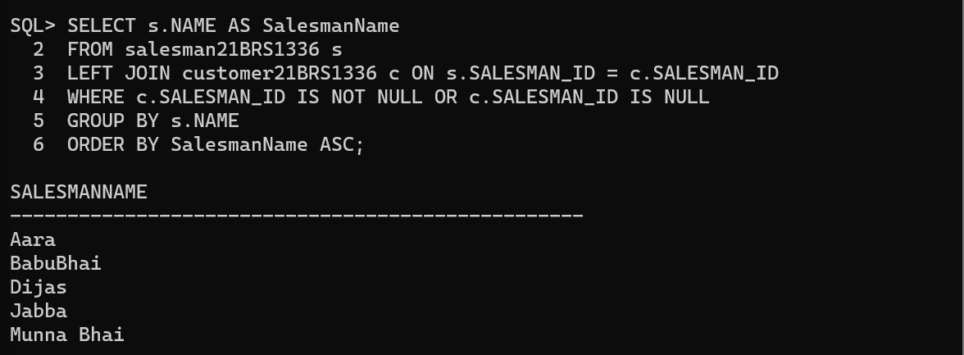

1. Make a list for the salesmen who work either for one or more customer or not yet join under any of the customers who placed either one or more orders or no order to their supplier.
2. Make a Cartesian product between salesman and customer i.e. each salesman will appear for all customers and vice versa.







